SAMV71 GPS Test Report

PD25 and PD26 shud be used as UART2 pins.
Enable satellite info:
- param set GPS_SAT_INFO 1
- param save
- reboot
gps start -d /dev/ttyS2 -b 38400



- gps status
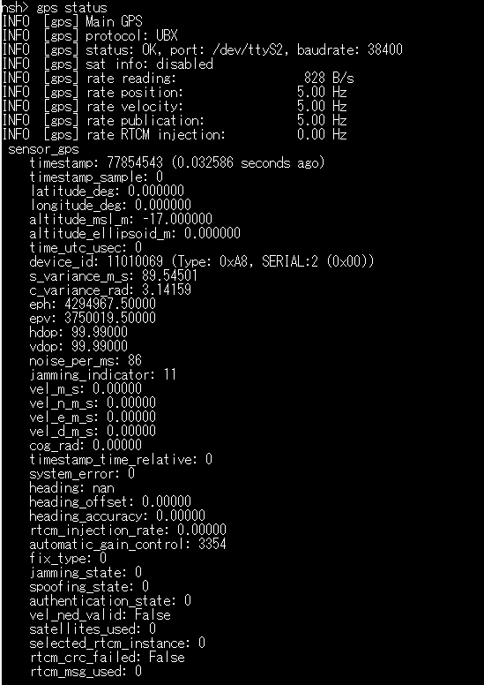

- listener sensor_gps
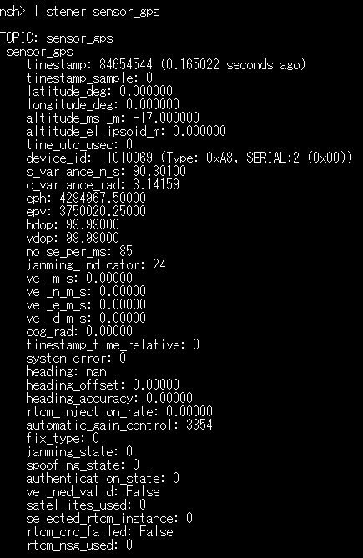

- listener vehicle_gps_position
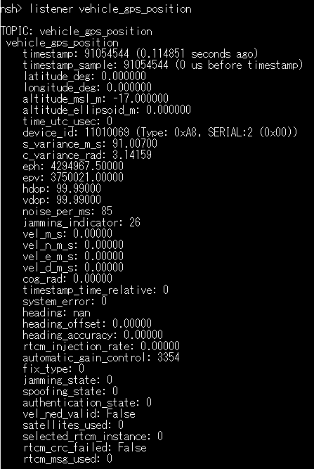
listener satellite_info
